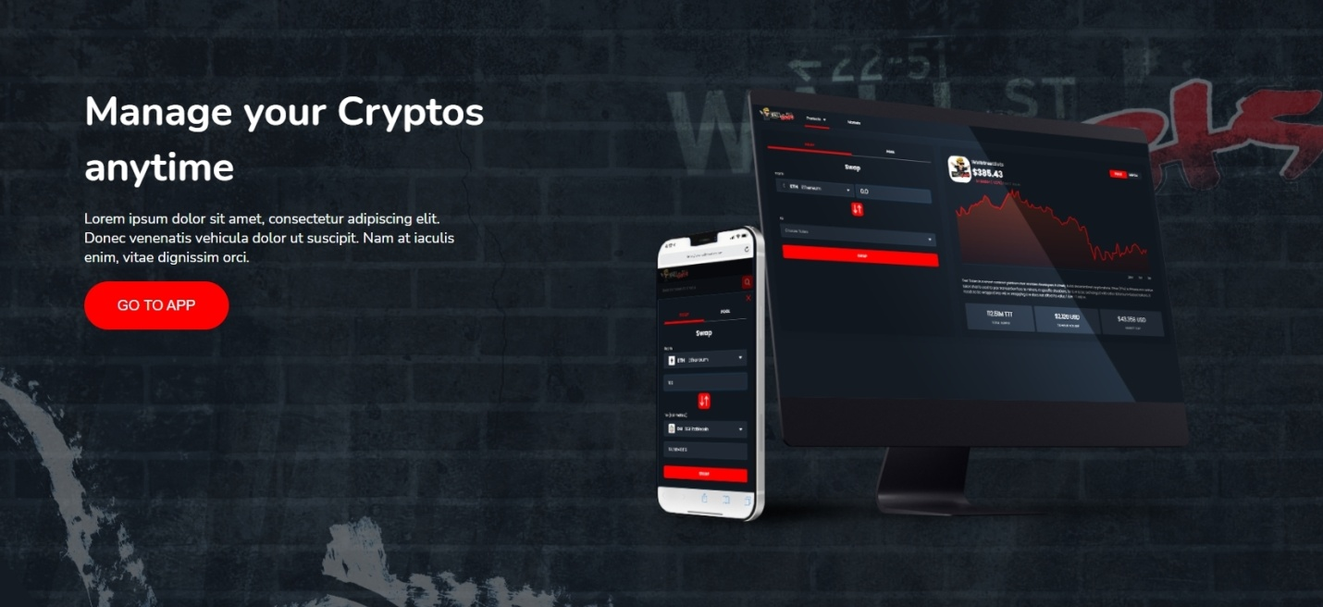

**WallStreetBets Token (WSB)**  
  
The WSB movement for financial democracy started on reddit and it became a global phenomenon. This is why decided to create a token to give our community a tool to grow their personal assets by farming the WSB token.

**GO TO APP (link to farming app)**

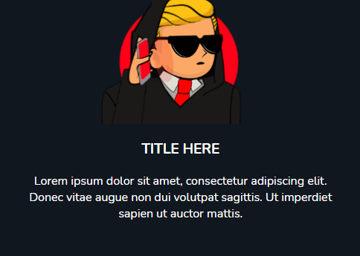

**TRADE LIKE A TRUE DEGEN**

**WSB provides you with the tools to trade like a true degen, farm WSB and more**

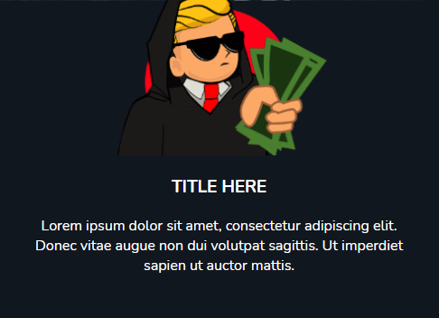

**DIAMOND HANDS ONLY**

**If you HODL WSB you get the tendies, Do not sell your WSB to the suits!**

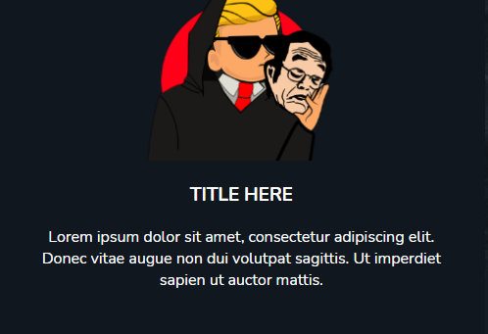

**A PROJECT BY SATOSHI STREET BETS COMMUNITY**

**We’re all in this together retards, we will HODL until the end**

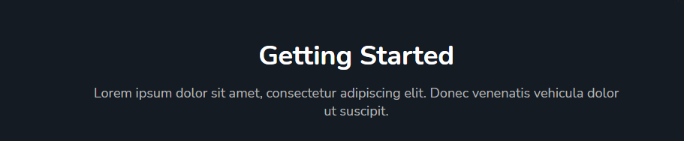

**Getting Started Has Never Been Easier  
Farming WSB token for LP providers on Uniswap WSB/ETH pool then locking UNI- V2 tokens**

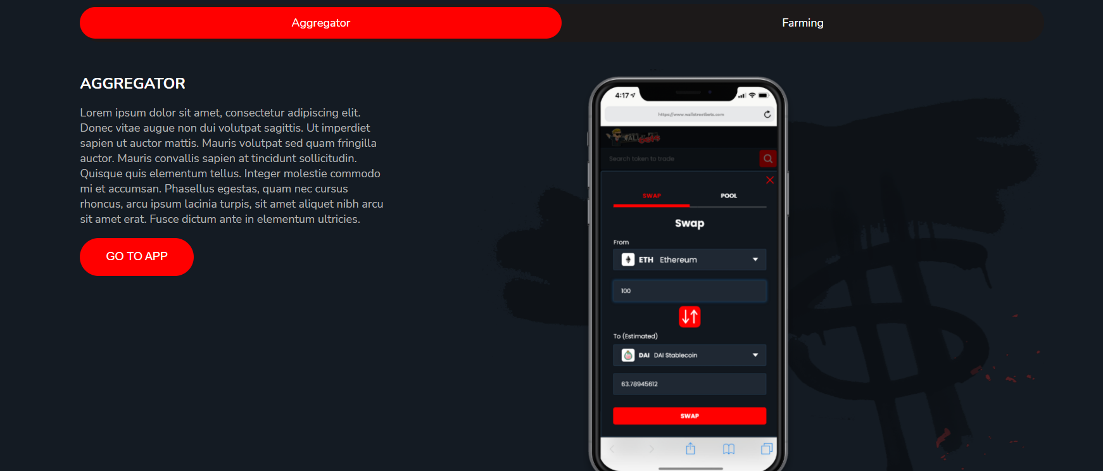

**Swap your tokens like a true degen on our new DEX aggregator**  
  
Our branded DEX Aggregator provides you with the best price and liquidity routing by aggregating over 13 DEXs  
  
Go to APP (no link for now we will provide u this later)

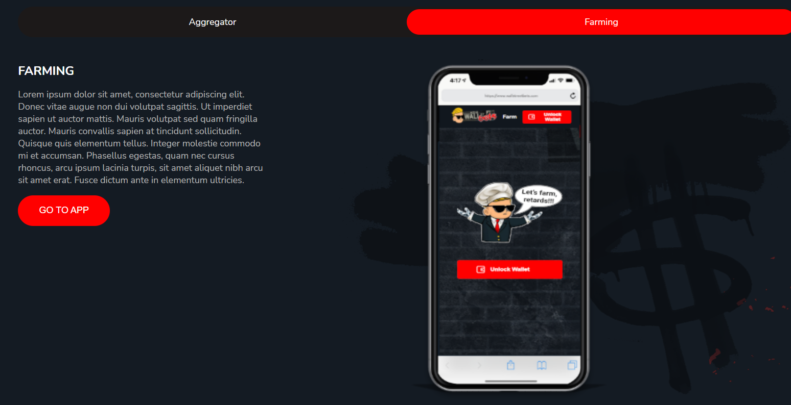

**Farming made easy**

Farming WSB tokens is easy, all you have to do is provide liquidity on Uniswap for WSB/ETH pair and lock your UNI-V2 tokens in our farming pools  
  
GO TO APP: link to the farming app

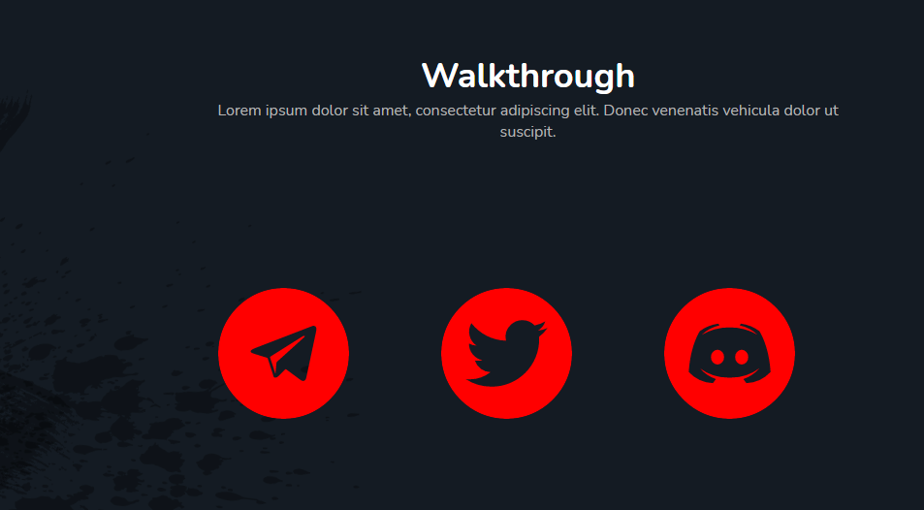

**Join our community**

<https://t.me/satoshistreetbets>  
<https://twitter.com/BetsPodcast>

**change discord logo to youtube icon**: https://www.youtube.com/channel/UCuvw3AlJmW-db0OTWNd1I-Q

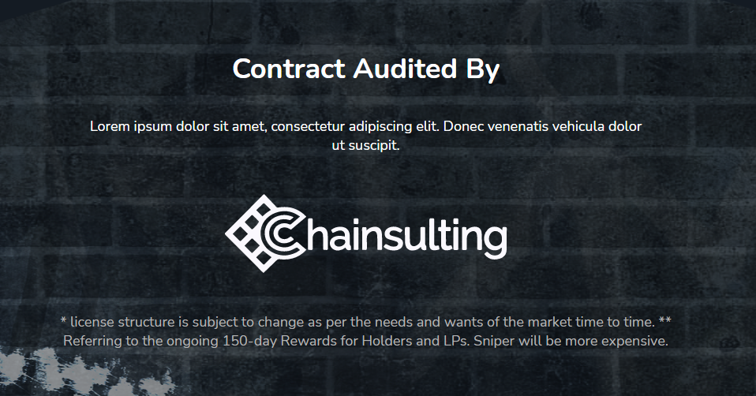

**Contract Audited By**

**Remove lorem ipsum text  
  
chainsulting logo* link to: https://chainsulting.de  
  
remove this text: *license structure……**

https://i.gyazo.com/c46fcadd3377bfa827e8a3ad1af9d68c.png

**Copyright 2021 WSB. All Rights Reserved.**